Volume/Schedule-Based Projects Closeout Instructions
Purpose:
To efficiently and accurately close out deliverable projects that have end dates through 3/31/2021.

Guidelines:
In order for a project to be closed, we must first ensure the following criteria are met:

- Project has ended
- Encumbrances are closed
- All revenue is accurately applied
- No invoices are open
- All expenses are accurately posted
- Accounts 7062/7072 are liquidated to a zero balance
- Accounts 3732/3734 are reconciled to ensure that only the first $25k of a subaward is charged to 3732

Step #1: Has The Project Ended Or Should The Date Be Extended?
- Determine if the project has ended. If the project is over, proceed to Step #2.
- If the project is ongoing and the end date needs to be extended, coordinate the extension with your assigned team in SPA.
  - Select “No” in ‘Close Project?’ column and enter the proposed end date in ‘Proposed End Date’ column.
  - Review the revenues and expenses for accuracy, but no further action is required on the spreadsheet for this project. If any discrepancies in the revenue or expense are identified, enter detailed remarks in ‘Additional Department Notes’ column.
  - The dates in Quantum will not be extended until SPAC is notified by SPA.

Step #2: Review Open Encumbrances and Pre-Encumbrances
- The ‘Total Obligations’ column contains the balance of open Obligations (Purchase Orders) and ‘Total Commitments’ column contains the balance of open Commitments (Requisitions).
- If the open Obligations or Commitments are valid, the project will not be closed until the encumbrances or pre-encumbrances are either paid or closed.
  - Enter “NO”, in ‘Additional Department Notes’ column and add detailed remarks in ‘Additional Department Notes’ column.
  - Review the revenues and expenses for accuracy, but no further action is required on the spreadsheet for this project.
- If all payments have been made on the encumbrance, email Keith Gagnon at kgagnon@umaryland.edu to request closing. The email needs to include the PO number and vendor name. Include RS SPAC-DLB Billing on the email so we will know when the encumbrance is closed.

Step #3: Review the Accuracy of Revenues and Expenses
- Review Unpaid Invoices. Are the open invoices valid? For a breakdown of the open invoice balance, go to the Awards Detail page in Quantum Analytics using the "What has been billed and collected on this Award" report selector
- Determine if any additional invoicing of the sponsor should occur and input detailed remarks in ‘Additional Department Notes’ column. The project cannot be closed if additional invoicing needs to be completed.
- Determine if all payments made by the sponsor have been posted to the project.
- Review the total expenses in LTD PROJECT BILLABLE COST and LTD AWARD BILLABLE COST columns. Determine if all expenses related to the Project/Award are posted. The project will not be closed until all expenses have posted.
- If the revenue and expenses are accurate, select “YES” from the dropdown box in ‘Additional Department Notes’ column.
- If the revenue and/or expenses are inaccurate, select “NO” from the dropdown box. Input remarks that identify the issues and the necessary corrections (ex. F&A rate should be 10%, revenue has been posted to my department revolving account, the final progress report has not been submitted, SPAC needs to invoice for $25,000).

By selecting “YES” in ‘Additional Department Notes’ column, you are certifying the project has ended, there are no valid encumbrances, all revenue is collected, and all expenses have posted.

Step #4: Address Surplus and Deficit Balances
- Review the data in Columns ‘LTD AWARD BILLABLE COST’ and ‘LTD AWARD INVOICED AMOUNT’ columns, which indicates the total amount of the surplus or deficit.
  - A surplus indicates the invoicing exceeds the costs. The department will retain the surplus.
  - A deficit indicates the expenses exceed the amount invoiced. The department will need to fund the deficit amount.
- Indicate project that the surplus/deficit entry should be processed to, along with the non-sponsored SOAPF that will receive the surplus or fund the deficit (‘SOAPF to use for Surplus/Deficit Transfer’ column).
  - Projects with incomplete or incorrect SOAPF information will be returned to the department for corrections.
  - Check Campus Reports > QFN129 Projects SOAPF Combo report from your homepage to confirm the combo is correct.
  - 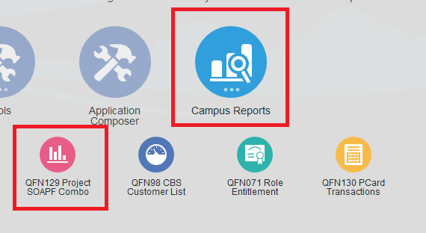
- Only input one SOAPF, as departments will be able to reallocate the surplus closing/deficit funding entry via Debit Memo after the closing entry has been processed by SPAC
- On projects where the invoices and expense net to 0, no SOAPF information needs to be populated, just populate the ‘Close Project?’ column to confirm that it’s okay for SPAC to close the Project.

